**CALL CENTRE DASHBOARD**

(Major Project)

By Ayushree Sharma

**Objective**

The objective of the "Call Centre Dashboard" is to provide a comprehensive analysis of call centre performance. This includes examining key metrics such as total calls, call duration, response time, and call distribution by various factors like day, reason, channel, sentiment, and geographic location. The goal is to identify trends, patterns, and areas for improvement to optimize call centre operations, enhance customer service, and ensure efficient resource allocation.

**Steps Taken**

1. **Data Collection:**
   * **Collected Data:** Gathered data on call centre operations, including total calls, call duration, response times, call reasons, channels, sentiments, and geographic locations.
   * **Formatted Data:** Ensured the data was in a compatible format like CSV or Excel.
2. **Data Loading:**
   * **Opened Power BI Desktop:** Started the Power BI Desktop application.
   * **Imported Data:** Clicked on "Get Data" and selected the data source (e.g., Excel, CSV).
   * **Loaded Data:** Loaded the data into Power BI.
3. **Data Cleaning and Preparation:**
   * **Removed Duplicates:** Eliminated any duplicate entries.
   * **Handled Missing Values:** Filled in or removed rows with missing data.
   * **Ensured Consistency:** Ensured all data was consistent (e.g., date formats).
4. **Data Relationships and Calculations:**
   * **Defined Relationships:** Set up relationships between tables if multiple tables were used**.**
   * **Created Calculations:** Used DAX to create necessary calculations (e.g., average call duration, response time percentage).
5. **Dashboard Design for Home:**
   * **Started a New Report**: Began with a blank report in Power BI.
   * **Added Visuals:** Added charts and graphs to represent the data:
     + **Total Calls and Call Duration:** Used cards to show totals.
     + **Response Time**: Used a KPI visual to show response time percentage.
     + **Call Distribution by Day:** Used bar charts to show call volume by day of the week.
     + **Call Reasons:** Used pie charts to show the distribution of call reasons.
     + **Channels:** Used bar charts to show the distribution of calls by channel.
     + **Sentiment Analysis:** Used bar charts to show the distribution of call sentiments**.**
     + **Geographic Distribution:** Used pie or bar charts to show call distribution by city and state.
   * **Added Navigation**: Implemented navigation features to allow users to easily switch between different sections of the dashboard(Home/Grid)**.**
6. **Dashboard Design for Grid:**
   * **Started a New Report**: Began with a blank report in Power BI.
   * **Added Visuals:** Added charts and graphs to represent the data:
     + **Total Calls and Call Duration:** Used cards to show totals.
     + **Response Time**: Used a KPI visual to show response time percentage.
     + **Added a table consisted of:** Customer Names, Id, Channels, States, Reasons, Response Times, Cities, Call Durations: Ranging from 10 to 44 minutes
   * **Added Navigation**: Implemented navigation features to allow users to easily switch between different pages of the dashboard(Home/Grid)**.**
7. **Customization and Formatting:**
   * **Adjusted Visuals**: Customized colors, labels, and titles.
   * **Added Filters:** Included slicers to filter data by different dimensions (e.g., day, channel, sentiment).
     + **Date Slicer**: Allows you to filter the data based on specific date ranges.
     + **Channel Slicer**: Enables you to filter the data by different communication channels such as Call-Centre, Chatbot, Email, and Web.
   * **Added Titles:** Added titles and descriptions to each visualization.
8. **Review and Sharing:**
   * **Checked the Report:** Ensured everything looked good and was easy to understand**.**
   * **Shared:** Exported the dashboard in PDF format.

**Dashboard Screenshots**

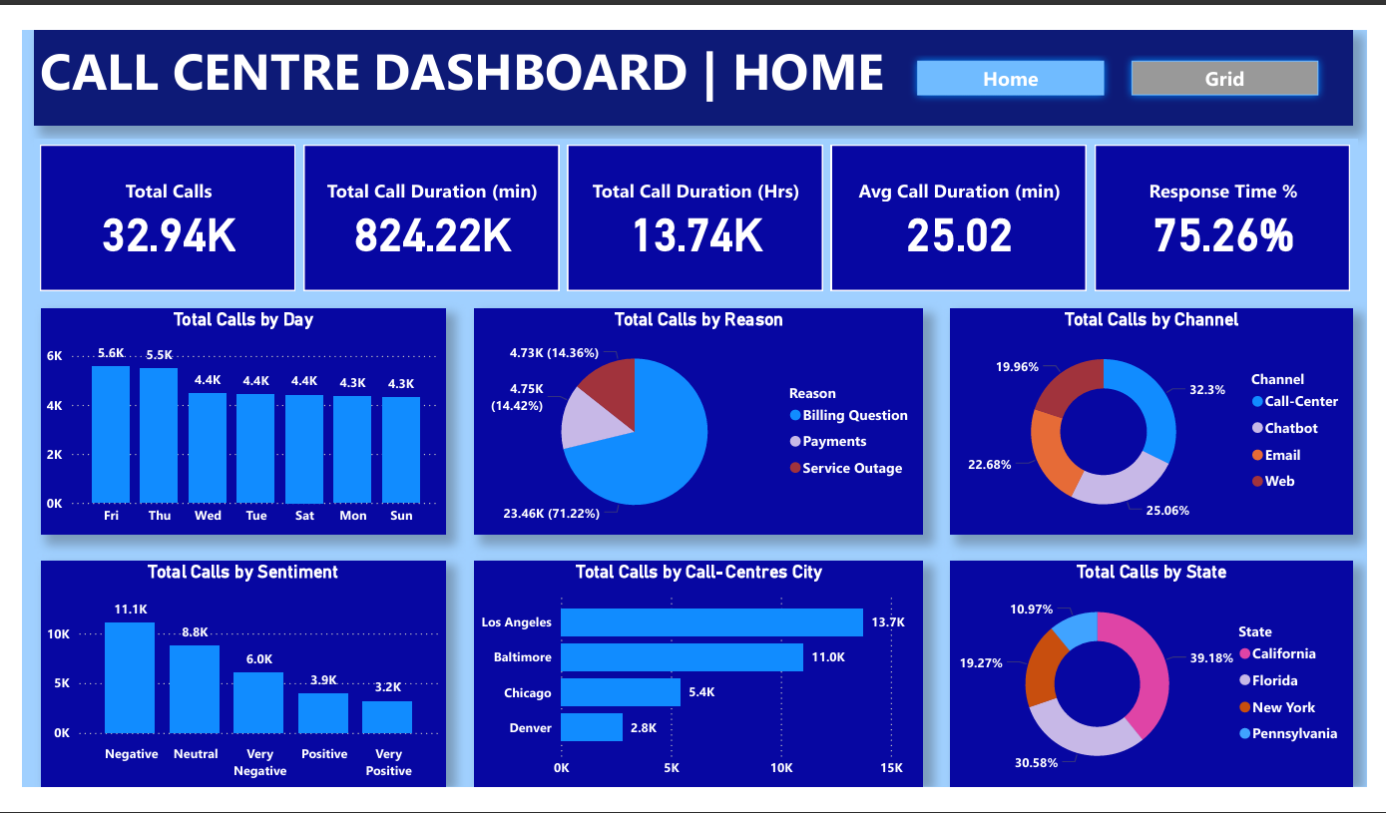

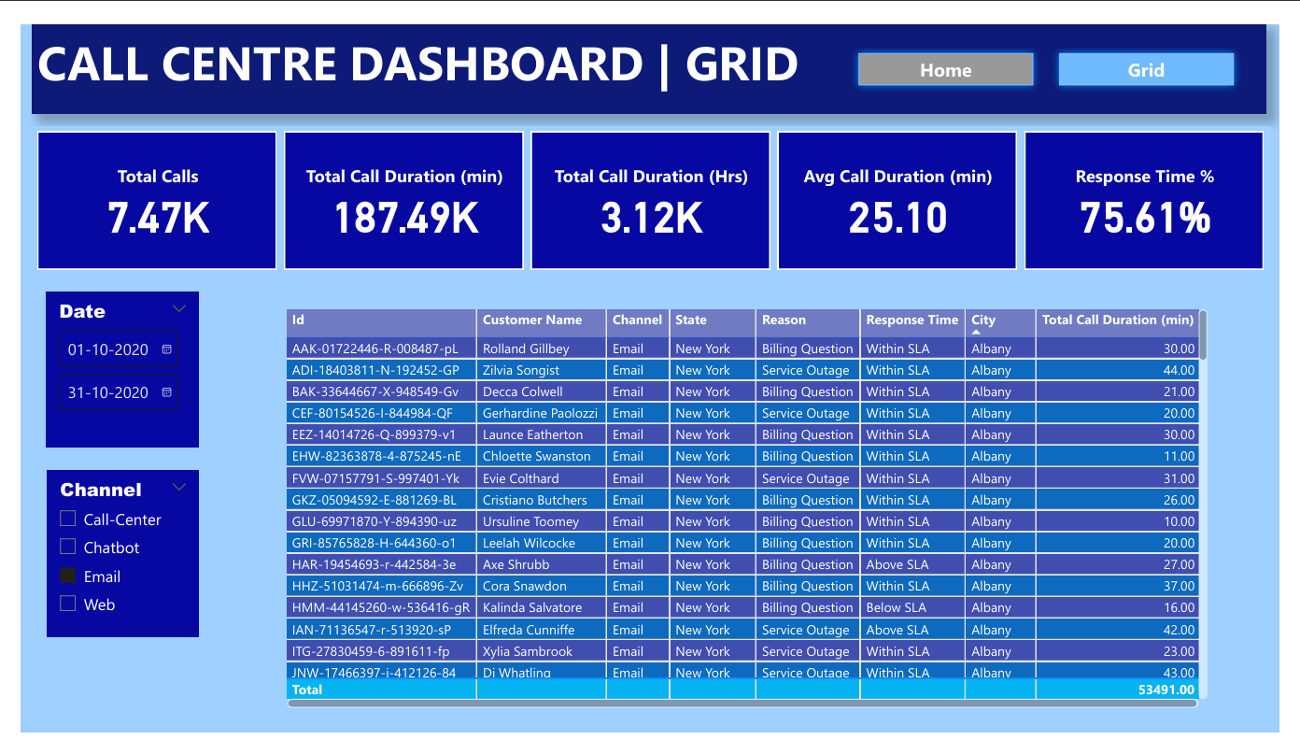

**Conclusion**

The "Call Centre Dashboard" analysis shows that the call centre handled 32.94K calls, with the highest volume on Fridays. The average call duration was 25.02 minutes, and the response time was 75.26%. Most calls were about billing questions, and the majority were handled by the call centre channel. Sentiment analysis revealed a mix of negative and neutral sentiments, indicating areas for improvement. The highest call volumes were from Los Angeles and California. These insights can help optimize call centre operations and improve customer service.